VBugs Worksheet 1

|  |
| --- |
| **Name:** |
| **Year Level:** |

**Answers to Part 1**

What is happening on your screen? Describe the output below:

|  |
| --- |
|  |

**Answers to Part 2**

Exercise1: *Reading the code*

1. Which line contains the code that tells the computer to

draw text on the screen?

1. Which line does contain the code that tell a computer to draw

a rectangle on the screen?

1. Where (line number) does the game loop start and end?

Exercise 2: *Changing the text*

1. Change the text "Hello World!" to "Hello *Your Name*!"

Write the code below that you changed to make this happen:

|  |
| --- |
| Answer:  …  'Draws text "Hello World"    'Refreshes the Screen and Processes Input Events  … |

Exercise 3: *Changing the color*

1. Change the color of the text to Color.GreenYellow.

Write the code below that you changed to make this happen:

|  |
| --- |
| Answer:  …  'Draws text "Hello World"    'Refreshes the Screen and Processes Input Events  … |

1. Change the color of the rectangle to Color.Blue.

Write the code below that you changed to make this happen:

|  |
| --- |
| Answer:  …  'Draws red rectangle    'Draws text "Hello World"  … |

1. Change the background color to Color.LightBlue.

Write the code below that you changed to make this happen:

|  |
| --- |
| Answer:  …  'Clears the Screen to Black    'Draws red rectangle  … |

**Answers to Part 3**

Exercise 1: *Locations on the screen*

1. In the area below draw a small rectangle with coordinates X = 15 and Y = 5 by hand.

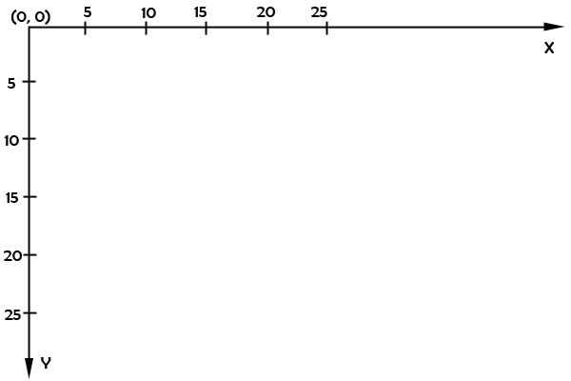

1. In the area below draw the text “Hello Your Name” at X = 5, Y = 20.

Exercise 2: *Changing drawing locations*

1. Change the location of the text; put it in the middle of the screen.

Write the code below that you changed to make this happen:

|  |
| --- |
| Answer:  …  'Draws text "Hello World"    'Refreshes the Screen and Processes Input Events  … |

1. Change the location of the rectangle; put it under the text.

Write the code below that you changed to make this happen:

|  |
| --- |
| Answer:  …  'Draws red rectangle    'Draws text "Hello World"  … |

Exercise 3: *Size of an element*

1. In the area below draw a rectangle with width = 5, height = 10 at the position X = 0, Y = 5.
2. In the area below draw a rectangle with width = 10, height = 5 at the position X = 5, Y = 10.

Exercise 4: *Draw an element with the new size.*

1. Change the size of the rectangle to width = 630 and height = 20.

Write the code below that you changed to make this happen:

|  |
| --- |
| Answer:  …  'Draws red rectangle    'Draws text "Hello World"  … |

**Extra Exercise:**

*Draw Smiley face on the screen then put the code you entered to achieve this below:*

|  |
| --- |
|  |